Feasibility Model Design

F2019 – Edit this document into a deliverable.

|  |  |  |  |
| --- | --- | --- | --- |
| Lab Section: | 6 | Group: | 2 |

# System-Level Design

Our ECE 298 projects start with a conceptual architecture, like the block diagram in Figure 1a). Specific example in Figure 1b). **Replace this figure with a high-level block diagram of your system.**

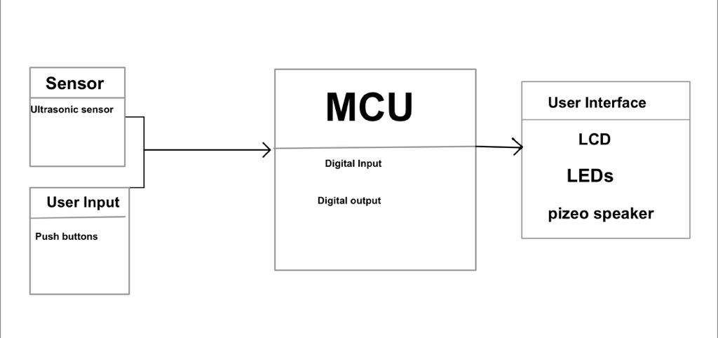

Figure 1b: Example using specific components and modules

## Project Design Requirements

In PD 21 you learned about engineering requirements. they fall into three major categories, as follows:

1. **Functional requirements** are quantities that specify the performance of a design. They are related to the functions of the design, identified as answers to the question, "What does it do?" For example, a functional requirement for a coffee maker may specify the time required to brew a pot of coffee, a DC power supply may specify its maximum voltage, and a vehicle alarm system may specify how much noise it makes when it is set off
2. **Non-functional requirements** specify characteristics of the design that are not performance based. Theses are typically features or qualities that are desirable to the client. For example, ease of use, ease of manufacturing, and use of recycled materials.
3. **Constraint requirements** place limits on the design space, and often reflect budget or other project limitations. For example, cost, weight, and noise.

The basic form of most of these requirements is the same: a short description, followed by a relationship (equals, less than, or greater than) and a value.

**State three to five major Functional Requirements that your project must meet to successfully solve your problem statement.**

1. The project intakes 4 inputs. 2 Ultrasonic sensors input readings and 2 push button inputs.
2. The project must display the output of the ultrasonic sensor readings, converting the sensor digital readings to a distance value to be displayed on the LCD.
3. The project must turn on a certain coloured LED corresponding to a distance value found from the front sensor value.
4. The project must also create 2 different sounds based upon the distance calculated from the back facing sensor value.
5. The project must also take in push button values that then correspond to setting up and configuring the MCU in either user mode or setup mode and the other push button should be able to set user threshold values.

## Project Sensors and User Inputs

* List the types of sensors and user inputs you may require (light, sound, temperature, magnetic field).
  + Ultrasonic sensor with distance Input x2. Ultrasonic sensor is connect as a digital input to the MCU and put through a Digital Signal Voltage Level Converter that steps the voltage up from 3.3 V to 5 to be read by the Ultrasonic sensor
* For each sensor and user input, list how you will connect it to the MCU, including additional interface components, if needed.
  + Push Button which are attached through GPIO pins and input data that is interpreted on the MCU.

## Project Actuators and Indicators x

* List the types of actuators and indicators you may require (e.g. light, sound, mechanical motion)
  + LEDs x3 (Red, Orange, Green)
  + Audio transducer connected to PWM pin
* For each actuator and indicator, list how you will connect it to the MCU, including additional interface components, if needed.
  + Each LED is connected with a resistance onto the GPIO pins.

## Project MCU Peripherals

* List the resources inside the MCU that could be used to implement your project (e.g. ADC, timers, interrupts, GPIO functions).
  + Ultrasonic sensor, push buttons and LEDs use a majority of the same functions which are written below.
    - GPIO_setOutputHighOnPin(),GPIO_setOutputLowOnPin(), GPIO_toggleOutputOnPin(),GPIO_clearInterrupt(),GPIO_enableInterrupt(), GPIO_selectedInterrupt(), GPIO_setOutpHighonPin()
* List parameters that the software running on the MCU might require.

## Project Testing Methodology

* For each sensor, user input, actuator, indicator, and MCU peripheral listed above, state how you will verify that each one is functioning as expected (a table may be helpful)

**WORK WITH WALEED**

* State how you will validate that each Project Design Requirement has been met

|  |  |  |  |  |
| --- | --- | --- | --- | --- |
| Push buttons | LCD Display | LEDs | GPIO functions | Interrupts |
| Use push buttons to cause interrupts to toggle LEDs | Outputs and display the values calculated from the values ultrasonic sonic | Use push buttons to toggle LED on | Used with every test device | Used in the functionality of the ultrasonic sensor display |

# Feasibility Model Diagram and Software Flowchart (High-Level)

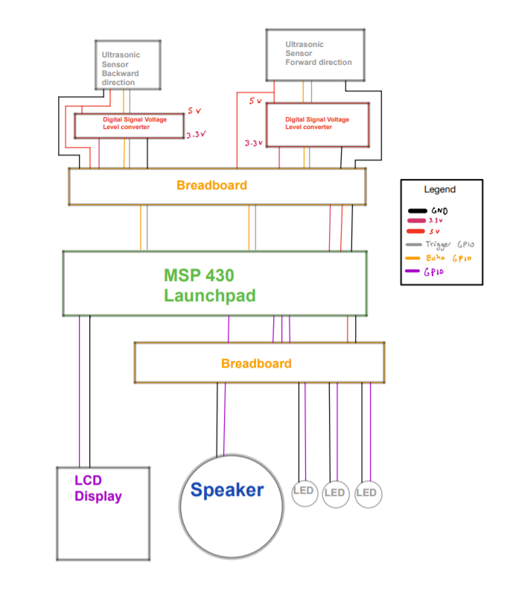

Figure : Simple Sketch of a Feasibility Model Design

## 

Figure : Simple Sketch of a Software Flowchart

## Initial Bill of Materials

* List what modules and components (including quantities) are needed from the ECE 298 Parts spreadsheet for your Feasibility Model Design

|  |  |  |  |  |  |
| --- | --- | --- | --- | --- | --- |
| PART NAME | Distributor Part No | ECE 398 DipTrace Part | RIGIDWARE SKU | RIGIDWARE PRICE (without TAX) | QUANTITY |
| MODULE - Ultrasonic Distance Sensor | Robotshop HC-SR04 |  | 4899825 | $2.40 | 2 |
| COMPONENT - AUDIO PIEZO TRANSDUCER 1-30V | "Digikey 433-1062-ND" |  | 4916287 | $0.85 | 1 |
| COMPONENT - RED LED - Diffused 5mm) | "Digikey 1497-1031-ND" | QPARTR5D34 | 4916296 | $0.40 | 1 |
| COMPONENT - ORANGE LED - Clear (5mm) | "Digikey 1497-1263-ND" | QPARTO5C34 | 4917122 | $0.40 | 1 |
| COMPONENT - YELLOW LED - Diff (5mm) | "Digikey 1497-1033-ND" | QPARTY5D34 | 4916429 | $0.40 | 1 |
| MODULE - Digital Signal Voltage Level Converter | Sparkfun BOB-12009 |  | 4923899 | $4.70 | 1 |